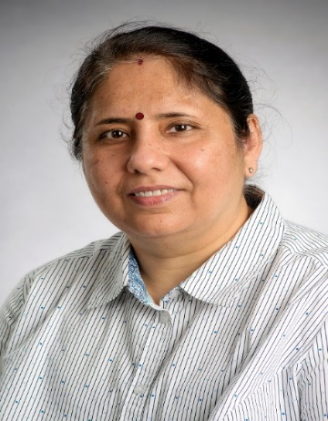
Dr. Latika Raisinghani has a PhD in Curriculum Studies with a focus on Science and Mathematics Education from the University of British Columbia. She is currently a Sessional Lecturer of Science, Mathematics and Environmental Teacher Education at the University of Regina and University of Victoria. Her teaching and research interests include critical multicultural and culturally responsive education, Indigenous ways of knowing and community engaged learning. Dr. Raisinghani is engaged in interdisciplinary research and teaching that aims to invite (trans-multi)culturally responsive education to empower diverse students, teachers, and school leaders, and strengthen academia-community interrelationships.
Research Presentation Title: (Re)searching (Trans-multi)culturally Responsive Science Education: Embracing Collective Responsibility for Empowering Diverse Students
Brief Overview: In this presentation, Dr. Latika Raisinghani will share her journey of (re)searching (Trans-multi)culturally Responsive Science Education and her contributions towards promoting responsive educational practices in India, Marshall Islands, Micronesia, and Canada. This will include key aspects and implications of her doctoral research which explored K-12 teachers’ perspectives of students’ cultural diversity and the viability of culturally responsive teaching in science and mathematics classrooms in an urban Canadian context as well as ongoing and future research initiatives in the broader area of science and mathematics education, critical multicultural education, teacher education and professional development.

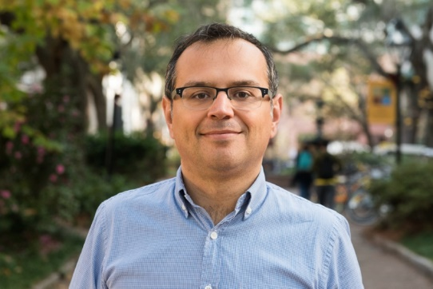
Dr. Nenad Radakovic is an Associate Professor in the Department of Teacher Education at the College of Charleston (South Carolina). Nenad received his MA and PhD from OISE/University of Toronto. He has experience as a teacher, researcher, and professor in both primary-junior and intermediate-senior school levels in Canada, Croatia, and the United States. A central theme of Nenad’s teaching and research is mathematics and STEM education for social justice. His teaching and research interests include transdisciplinary STEM education, teacher education, the pedagogy of risk, and diversity, equity, and inclusion issues in education. In his free time, Nenad enjoys playing guitar, songwriting, reading about math and science, and connecting with family and friends.
Research Presentation title: Transdisciplinary Approaches in STEM Education
Transdisciplinarity is a research and educational approach that combines, blurs, and transcends disciplines in order to create an authentic context where communities can work together to generate scientific and social change. In this presentation, I will describe how transdisciplinarity can be used as a lens to make sense of STEM education and curriculum. Various aspects of my research on transdisciplinarity, such as the critical pedagogy of risk and transcending mathematics education through art, design, music, and poetry, will be presented. Finally, I will outline how transdisciplinary education offers a way to humanize STEM for all students.

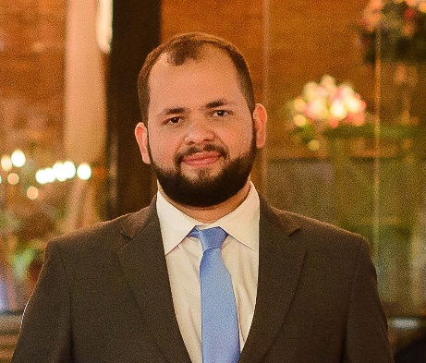
Cristiano Moura holds a Ph.D. in Science, Technology and Education with a thesis on History of Science in Science Education. He is currently a member of the International History, Philosophy and Science Teaching Group Executive Board and was recently awarded a special grant for Young Scientists at Rio de Janeiro. His main interest is in intersecting approaches based on HPSS in Science Education with contemporary demands for justice-oriented science education in different spheres. For this, he uses insights from curriculum theory, decolonial and postcolonial perspectives, the Cultural History of Science and Science Studies.
Research Presentation Title: History, Philosophy and Sociology of Science for Science Education in a damaged world: pushing boundaries and challenging traditions
The use of historical approaches in science education is a long-standing tradition both in research and in curriculum development in the field, generally linked to the exploration of epistemological aspects of science. However, recent demands for justice-centred and for a socio-political turn in science education have been challenging the ways one uses to teach and learn science in schools. Considering that, I will explore new perspectives for science education based on the history of science and for the very boundaries of what is meant by science education currently. Navigating themes like decolonization, nature of science, and contextualization (among others), I will present empirical and theoretical research I have been publishing and also future projects I envision as a future faculty member of Queen’s University.

